Apache POI – Import Workbook Data

Interface Workbook



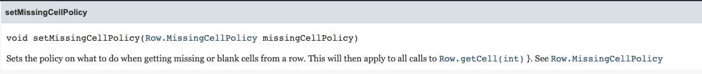

Enum Row.MissingCellPolicy

Interface Sheet









Interface Row







Interface Cell



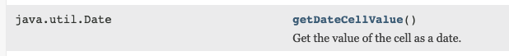



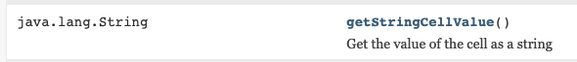



Enum CellType

